Bibliographic Information
The Boat People
By Sharon Bala
On Sale: 3/27/2018
ISBN 9780385544023
Doubleday Publishing

For readers of Khaled Hosseini and Chris Cleave, The Boat People is an extraordinary novel about a group of refugees who survive a perilous ocean voyage only to face the threat of deportation amid accusations of terrorism.

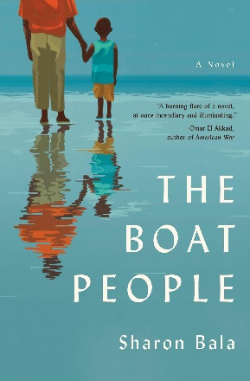

Objective & Summary
This incredibly relevant title has caught the attention of the International Sales Team at Penguin Random House as many countries around the world are struggling with displacement while others are finding themselves in the midst of a refugee crisis. We would like to suggest this title for the One World, One Book program – a premium global marketing and sales program. The below marketing plan will help the title get the attention it deserves. Only a handful of titles are internationally relevant enough to be admitted into the program each year. Key markets for the title are Germany, France, Singapore & Malaysia, the Philippines, Saudi Arabia, United Arab Emirates, Australia & New Zealand, the Netherlands and the UK.
Campaign Elements
Pre-pub
- Announcement of title as the first 2018 “One World, One Book” November 2nd, 2017
- Buzz-building among our accounts with sell sheet and global marketing plan
- Ad bookings in distributor catalogs, including Libri’s Just the Best
- Large galley mailing of 200 to 300 galleys with personal letter to accounts and influencers
- Collection of international book seller quotes to add to back cover of export edition
- Establish “account embassadors” in each territory
- Goodreads Giveaway campaign leading up to on-sale
- Netgalley widget or pre-order campaign
- Line-up international media including author interviews
  - Open market media pitches NY team, publicists on the ground in Singapore & Malaysia
  - UK media pitches UK-based publicist
  - Australia & NZ pitches ANZ team
- Offer author Q&A’s to accounts

On sale
In-store display and promotions:
- Paid prime in-store placement
- Paid window displays
- Airport promotions
- Posters, bookmarks and other in-store merchandising upon request
Marketing Push:
- Signed copies for giveaways and promotions
- Paid online banner ads on account’s etailer site
- Paid print ads in account communication
- Google Ad campaigns linking to account website
- Amazon.de, and Amazon.fr coop promotions
- Global blogtour
- Boosted Facebook Posts to readers of Readers of Khaled Hosseini and Chris Cleave
Publicity
- Pitch title to PRH’s extensive international media contact base
- Leverage author’s network
- Interviews & book reviews around the world
- International publicity tour including visit to the Philippines
Post On Sale
Sustained Push throughout 2018
- Tie-in events to author’s international travel schedule, if possible
- Highlight title at all 2018 International Book Fairs
- Pitch author visits to all international Literary Festivals
- Share and boost account success stories through social media channels
- Track sales of translation rights, focus promotions on countries with local language editions
For more information or to receive your galleys and customized marketing plan please contact Christine Swedowsky at cswedowsky@penguinrandomhouse.com.

